**Link to our Repo**

**Aquatix**

https://bitbucket.org/team5c/hidden-leaf

**Contributions**

* Designed and created static pages like FAQ page and populating them with meaningful questions.
* Designing a team roles page, milestones page and remaining work plan page.
* Also designed About Us page.
* Performing unit testing of webpages with identification module.
* General bug fixes in pages which included fixing links in webpages

**Screenshot of our Home page:**

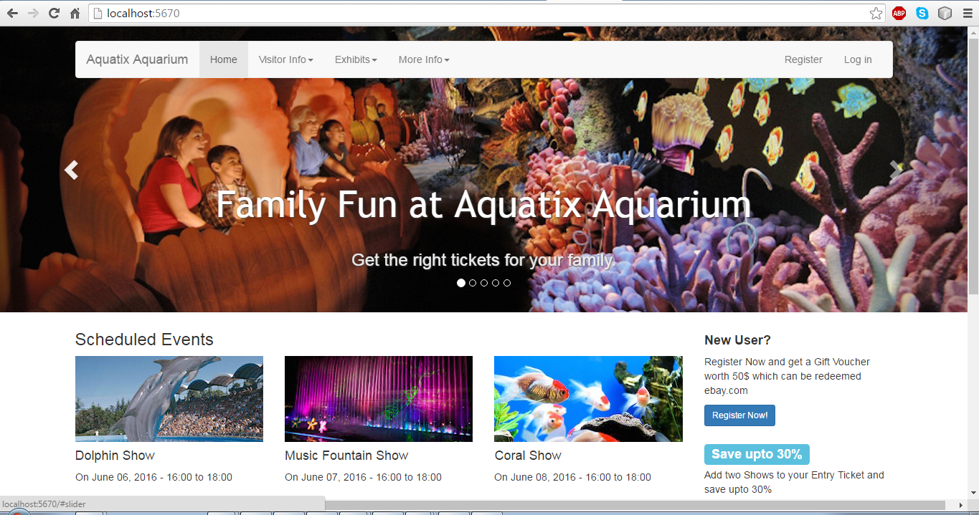

**References**

All the data and images used in our application have been acquired from ***Google images***